**Guidance of installing PDIOTAPP**

**2. Installation guide.pdf (file) containing :**

**a. System requirements:**

API Level: minimum Sdk Version 30

Target Sdk Version 30

The frequency of respeck and Thingy should be changed as 25 Hz

**b. Installation instruction**

After entering the app, browse the menu interface and select connect sensors button to connect respeck and thingy.

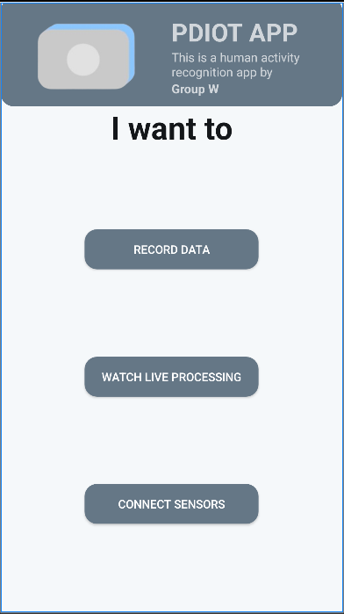

Then scan the QR code on the back of respeck to connect to respeck, use nfc or enter the MAC address to connect to thingy.

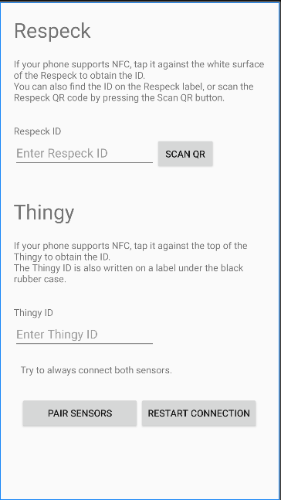

Then back to the menu page. And select the watch live processing to view the live data and predict the motions.

The first two tables are used to display the live data of respeck and thingy. The Respeck predict table prints the respeck model (The model trained by the respeck data)'s predictions for real-time actions and provides prediction confidence.

The Thingy predict table prints the Thingy model (The model trained by the thingy data)'s predictions for real-time actions and provides prediction confidence.

The All predict table prints the all model (The model trained by the respeck and thingy data)'s predictions for real-time actions and provides prediction confidence.

The Predictions over the last 10 seconds table shows the statistics of the activity and confidence of the highest probability predicted by each model in the past 10 seconds, and the activity and confidence of the second highest probability.

The start button is a binary button used to start prediction and stop prediction. When start is pressed, the app starts predicting the motion and the button changes to stop and vice versa.

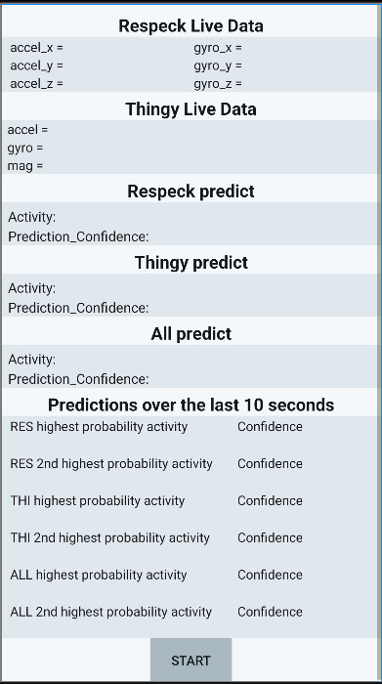

**d. List of non-standard python packages:**

scipy, sklearn, numpy, pandas, tensorflow, seaborn, pylab, matplotlib